# CS 255 System Design Document Template

This template lays out all the different sections that you need to complete for Project Two. Each section has guidance to prompt your thinking. You will need to continually reference the interview transcript as you work to make sure that you are addressing your client’s needs. There is no required length for the final document. Instead the goal is to complete each section based on what your client’s needs are. Remove this note when you are finished, and replace all bracketed text with the relevant information.

## UML Diagrams

### UML Use Case Diagram

### UML Activity Diagrams

### UML Sequence Diagram

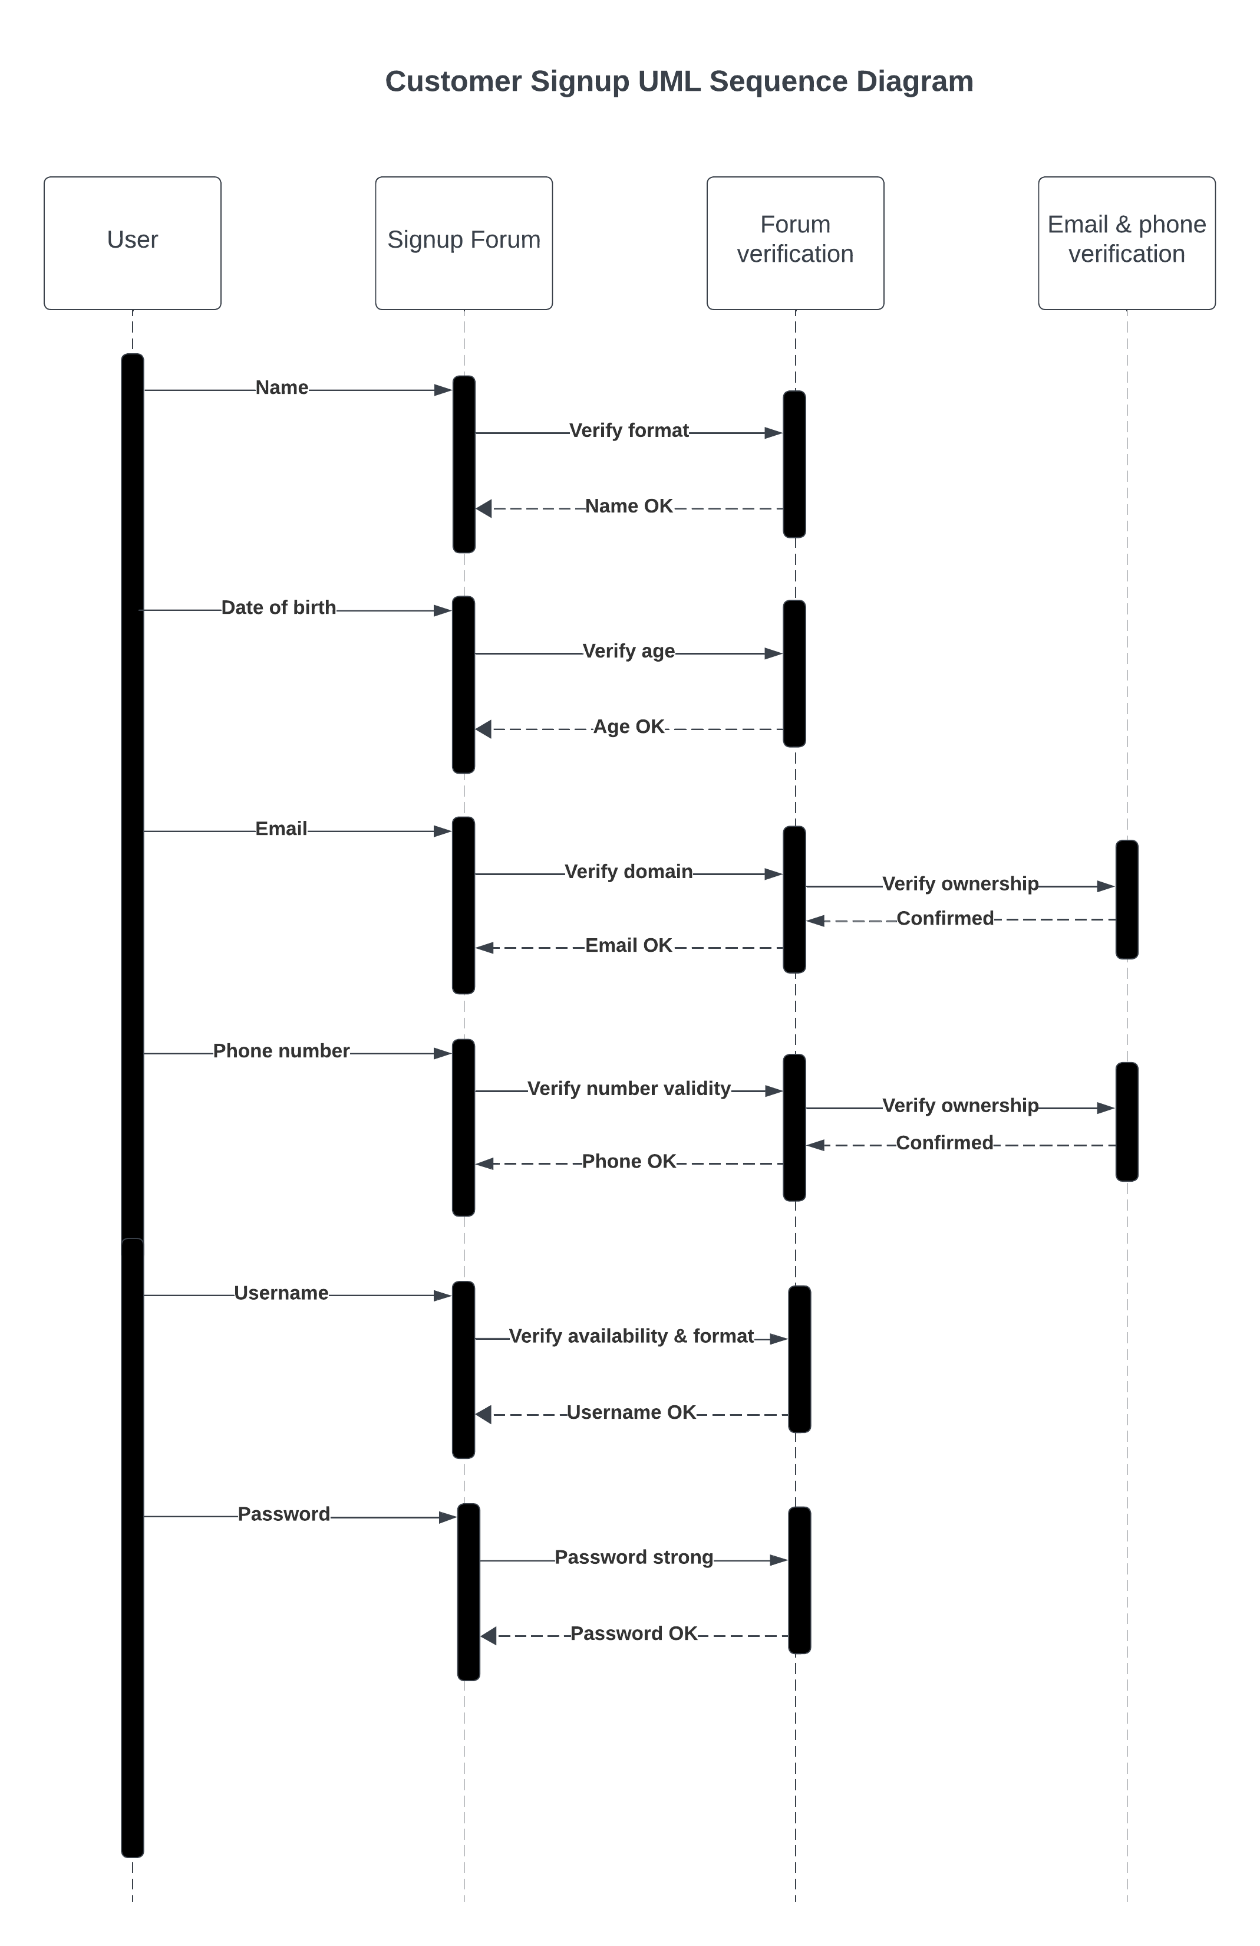

### UML Class Diagram

*[You were asked to create a class diagram based on the different classes and attributes needed for your system design. You are* ***not*** *required to include methods, but you may if you wish. Please insert your class diagram here. Check to make sure that you included appropriate components and symbols and that your design meets the client’s requirements.]*

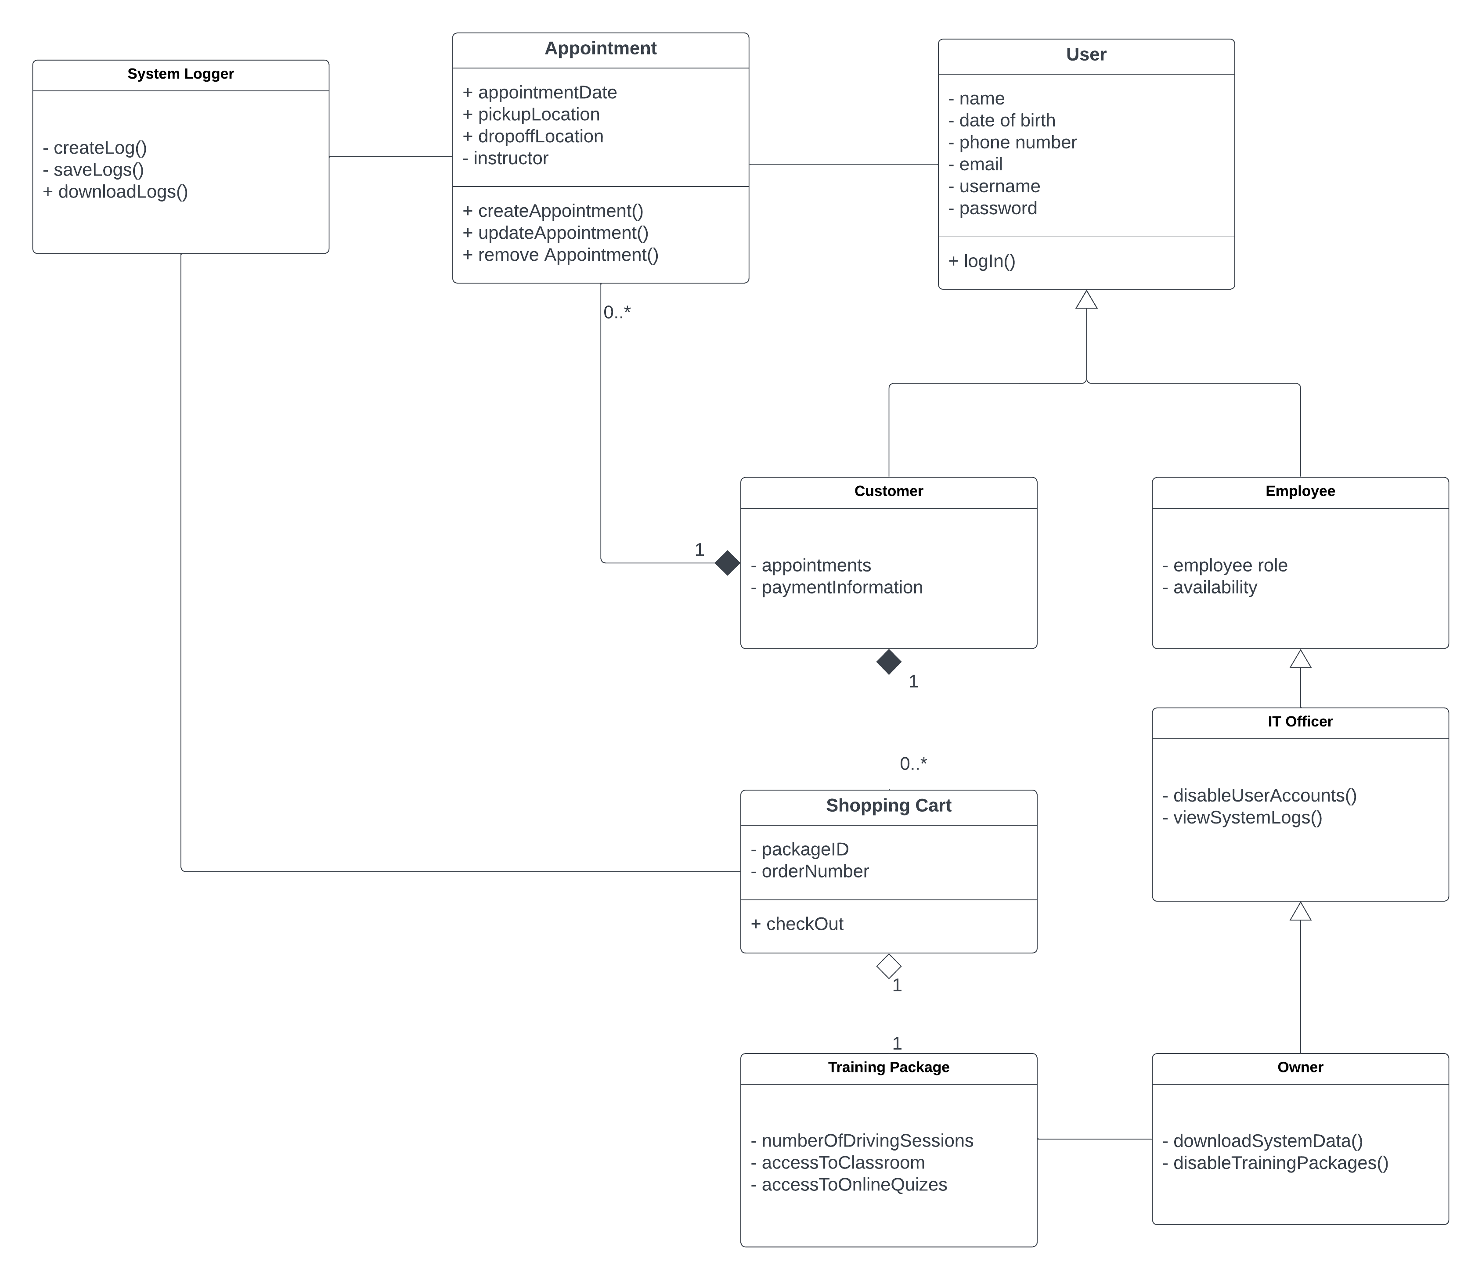

## Technical Requirements

*[Based on the diagrams you have created, describe the technical requirements of your system. These requirements should address the required hardware, software, tools, and infrastructure necessary for your system design.]*

|  |  |
| --- | --- |
| **Technical Requirement** | **Description** |
| Python programming language (3.12 or newer) | High level programming language with support for object-oriented programming and numerous libraries for web development, data analysis, etc. |
| PyCharm Community Edition (or Professional) | IDE with support for debugging, refactoring, and testing, enhancing productivity. |
| Git and GitHub | Version control software and managing remote repositories. |
| PyUnit | Python testing framework for writing unit and integration tests for system modules |
| Flask | Micro framework for developing web applications in Python. |
| MongoDB | NoSQL database management system that is fast, flexible, and scalable. |
| SQLAlchemy | Flask provides direct support for SQLAlchemy via the sql_alchemy package. It adds support for developing relational database systems using SQL. |
| Bootstrap 4 | Front-end web development framework for building web pages that adapt to any screen size, perfect for both mobile and desktop clients. While Bootstrap 5 is more feature-rich than its predecessor, version 4 is simpler to learn and supports more, older browsers, such as Internet Explorer 10 and 11. |
| Jinja | Web template engine that allows adding programming elements into our HTML documents directly from our python code. Additionally, it allows us to add object-oriented elements, such as inheritance, to HTML, which is a simple markup language. |
| Google reCAPTCHA | Service for added security against bots and automated, injection attacks on the system. |
| AWS EC2 | Hosting a cloud-based Linux server via Amazon Web Services, Elastic Compute Cloud (EC2). |
| Cloudflare DDoS | External protection against Denial of Service (DDoS) attacks on system |
| Cloudflare SSL/TLS | Encryption service for end-to-end encryption in the HTTPS protocol, to prevent data theft or transmission intercept for when sending data over the internet. |